Student’s name | …………………………………………………….…… | Grade | 3
Subject | Computer | Week No. | 7
Lesson Title | Page Design | Unit
Worksheet No. ( 7 ) (Answer)
Question A:
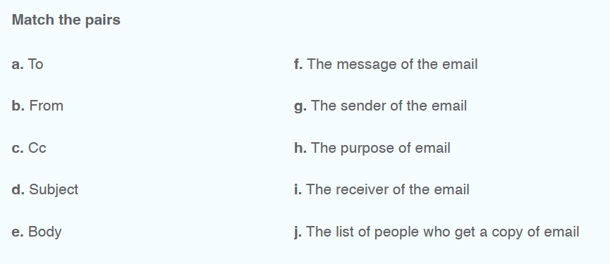
Good Luck

